COSTS AND BENEFITS OF NEOLIBERALISM.
A CLASS ANALYSIS
Gérard Duménil+ and Dominique Lévy++

RÉSUMÉ
COÛTS ET AVANTAGES DU NÉOLIBÉRALISME. UNE ANALYSE DE CLASSE
Le néolibéralisme est l'expression idéologique du retour d'une fraction des classes dominantes, la finance, à l'hégémonie. On ne peut saisir la logique de ce mouvement qu'en le replaçant dans sa dynamique historique. La finance moderne, liée au système productif, apparut dans le sillage de la crise structurelle de la fin du 19ème siècle. Elle dut abandonner sa domination incontestée dans le compromis keynésien provoqué par la succession de la crise de 1929 et de la Seconde Guerre mondiale. Sa remontée au pouvoir s'est opérée à la suite de la crise commencée dans les années 1970. Le caractère de classe du néolibéralisme est inscrit, très crûment, dans les chiffres: prolongation de la faiblesse du taux de profit des entreprises non financières, donc de la croissance lente et du chômage, déficits et endettement des États, crise de la dette du tiers-monde, etc. Mais le bénéfice que la finance tira de son hégémonie retrouvée n'est pas suffisamment dénoncé: hausse formidable de son revenu et explosion du secteur financier, seulement différées aux États-Unis du fait de la crise des institutions bancaires et d'épargne pendant les années 1980. Ce n'est pas que la finance s'organisât pour souffrir le moins possible de la crise, mais qu'elle en tira un profit difficilement imaginable, soit pendant la crise, comme en France, ou après, comme dans le secteur financier américain. Sans négliger la misère des chômeurs, des exclus et du tiers-monde, l'instabilité systémique dont la nouvelle hégémonie de la finance est responsable, pourrait s'affirmer comme son principal coût.

ABSTRACT
COSTS AND BENEFITS OF NEOLIBERALISM. A CLASS ANALYSIS
Neoliberalism is the ideological expression of the return to hegemony of the financial fraction of ruling classes. The meaning of this movement can only be understood from a historical perspective. Modern finance, linked to the real economy, appeared in the wake of the structural crisis of the late 19th century. It lost its unrivalled domination, when the Keynesian compromise was ushered in by the succession of the great depression and World War II. Its return to power followed the crisis which began in the 1970s. The class character of neoliberalism is evident from an examination of the available figures. It prolonged the deficient profit rates of nonfinancial corporations and, thus, slow growth and unemployment. It was responsible for the deficits and the growing indebtedness of the states, as well as for the crisis of the debt of third-world countries, etc. But not enough attention has been paid to the benefits that finance gleaned from its return to hegemony during the crisis: the stunning rise of the profits and growth of the financial sector, only delayed in the U.S. by the banking and thrift crises of the 1980s. It is not that finance organized to minimize its own costs during the crisis. It actually benefited from the crisis in amazing proportions, already during the crisis as in France, or after as in the U.S. financial sector. One should not underestimate the sufferings of the unemployed and homeless, or of third-world countries. But perhaps the biggest cost stemming from the rise of finance is the increase in the domestic and international instability.

This is an updated version of the paper originally published as: Duménil G., Lévy D., 2001, Review of International Political Economy, Vol. 8, #4, 578-607.

Introduction
Most, if not all, analysts on the left now agree that neoliberalism is the ideological expression of the reassertion of the power of finance. The term itself, finance, refers to a framework of institutions, interlocked in a complex network; behind these institutions, stand individuals. Although it may not be easy to outline the contours of this entity, in particular in relation to the development of pension and mutual funds, the new leadership of the upper and active fraction of finance is quite conspicuous since the end of the 1970s. The rise of real interest rates is obviously favorable to lenders; the new global distribution of production is clearly directed by large banks; the stock market is center stage; the managers of corporations are compelled to target their activity, even more strictly than before, toward the maximizing of the market value of corporations and the distribution of large fractions of profits as dividends. All these features of contemporary capitalism point to the crucial position of finance, at the center of the new neoliberal setting.
Although the return of finance to hegemony was accomplished in close connection with the internationalization of capital and the globalization of markets, it is important not to misinterpret the relationship between these various phenomena. It is finance that dictates its forms and contents in the new stage of internationalization; it is not internationalization or globalization that create the insuperable necessity for the present evolution of capitalism.
Once the leadership of finance has been identified at the root of neoliberalism and the internationalization of capital, one is very close to an interpretation of recent trends in class patterns. The assertion that a set of institutional transformations and policies was devised in favor of a wealthy minority directly points to the division of society into classes, and to the underlying struggles. Only two basic contentions must be added to obtain an outline of the contours of an actual Marxist framework of analysis: (1) Capitalism recurrently evolves toward large structural crises, that it only supersedes at the cost of large transformations of its basic functioning; (2) The trends of the profit rate, in particular its phases of actual decline, are crucial in the occurrence of these crises. Thus, the perspective in this study is that of Marxist analysis, combining the reference to relations of production and class struggle with the typical Marxist economic analysis of tendencies and crises. The costs and benefits of neoliberalism are considered in a historical perspective (in particular, in the context of the structural crisis of the 1970s and the new trends in technology and distribution that have appeared since the mid-1980s), and in relation to class and power relations. In both of these respects, the analysis is straightforward and limited in scope.
The way neoliberalism is depicted in this study combines historical and quantitative analysis. (Crude figures are often so telling that not much needs to be added to make the point.) This paper divides into four sections:
1. Our interpretation of the history of capitalism during the last century can be briefly sketched in a few propositions: (1) The framework of modern finance did not always exist, and the analysis must begin in the early stages of its formation, at the end of the 19th century; (2) The upper fraction of finance—the capitalists of contemporary capitalism—always fought for the perpetuation of its dominance, i.e., for the perpetuation of capitalist relations of production; (3) After its relative setback during the Keynesian years (in the wake of the Great Depression and World War II), finance made considerable headway during the two later decades, using the new structural crisis.
2. The costs of neoliberalism for other classes have often been described. They are only briefly recalled in the paper: extension over time of slow growth and unemployment, the rising debt of the third world and states, and the emergence of the new neoliberal order with its specific social violence.
3. The actual benefits, in the most straightforward sense of the term, realized by finance during the last two decades have less often been demonstrated. But the data are unambiguous: A particular class and a sector of the economy, that we globally denote as finance, benefited from the crisis in amazing proportions. Facing the incredible misery of the third world, and unemployment both in the center and periphery, the rising wealth of the wealthiest fraction can be easily documented. Households holding monetary and financial assets benefited from the change in policy. Everywhere, the rise of real interest rates transferred large resources into the financial sector. This was quite conspicuous in France, and temporarily obscured in the U.S. by the banking and thrift crises of the 1980s, but finally became evident. Large amounts of capital, attracted by large profit rates, were invested within the financial sector.
4. The analysis of the present financial fragility is complex. But it is at least easy to show that it is deeply rooted in the nature of finance, in the autonomy it has conquered vis-à-vis real activity and state intervention.
In the analysis of these historical evolutions, we will rely to a considerable extent on the example of the U.S.. The rest of the paper also deals with other countries: Europe and the third world.
The various figures presented in this study are based on computations using standard data bases. Some of these computations are straightforward, others are more sophisticated. They often refer to rather well-known or intuitive phenomena, though their amplitude is probably often underestimated. The technical aspects are not made explicit, and will be communicated on request.

1 - Finance in power: Mutation of relations of production and class domination
Modern finance emerged in the late 19th century. Prior to that time, a large fraction of the activity of finance was linked to the financing of public expenses. A major transformation occurred at the turn of the century, when a new financial framework developed, closely related to the economy.
This transformation occurred during the structural crisis of the late 19th century. Most economic historians agree concerning the existence of a long period of “stagnation” in Europe at the end of the century, but the situation was, to some extent, different in the U.S., because of the specific features of this country during these years (a country of immigration and importation of capital) and because of the Civil War. Two major crises were observed, one during the 1870s, closely related to the deflation following the Civil War, and the other during the 1890s. In between, a sharp expansion took place in the early 1880s, following the return to convertibility of the dollar (suspended since the war).
This period of major instability and crisis followed a previous phase of technical change à la Marx, several decades long, in which the progress of labor productivity was only obtained at the cost of the investment of large amounts of constant, in particular fixed, capital (periods of rising technical and organic compositions of capital), with a downward trend of the profit rate. Under these circumstances, an important crisis of competition occurred, in which firms attempted to gain protection from the general low profitability levels, through various agreements. This was the era of cartels and trusts.
Two types of legal innovation had important consequences on the economy. On the one hand, the Sherman Act (1890) established the first federal antitrust legislation. On the other hand, a new legal framework was established (beginning in New Jersey), favorable to incorporation, in particular to the formation of holding companies. Actually, the law forbade any type of consolidation in which independent firms were organized to share markets, pool profits, etc., but it did allow straightforward mergers. A huge wave of mergers followed the crisis of the 1890s, just at the turn of the century, establishing a new framework of capitalist institutions.
Two distinct terms are used to account for these transformations:
1. The expression corporate revolution refers to the formation of large corporations, backed and controlled by finance. Was there a “merger” between finance and former industrialists, or was industry taken over by finance? The issue remains controversial (W.G. Roy, 1996). Relevant to our argument is the emergence of this new large finance and its relationship to industry. Finance was at the center of the new economy, controlling credit mechanisms (tightly connected to the stock market) and, thus, the issuance of money. The development of monetary and financial mechanisms during the first decades of the 20th century was spectacular.
2. The expression managerial revolution denotes the transformation of firms, now managed by staffs of managerial and clerical personnel (A.D. Chandler, 1977). These new procedures of management were tightly related to the Taylorist and Fordist organization on the shop floor, but affected all aspects of the activity of corporations (besides production, trade, management of inventories, liquidity, personnel, etc.). The distance between the workers and their means of production again widened, their tasks being defined by other salaried personnel. However, the managerial revolution was also responsible for new more favorable technological trends.
This transfer of managerial tasks to the business staffs was a matter of concern for owners (A. Berle, 1960). What autonomy to follow their own interests were managers able to obtain? The early 20th century was the era of technocratic trends in the U.S. (T. Veblen, 1983). How was the maximizing of the profit rate to prevail as the criterion of good management in conformity with the interest of the owners? Without being Marxists, the contemporary analysts of these new trends realized the importance of this transformation of capitalist relations of production, since the ownership of the means of production was at issue, and the new class of managers represented a threat to the owners of capital.
Thus, in the late 19th century, there emerged a new configuration of capitalism. A basic feature of this situation was the separation between ownership and management, and a new role of financial institutions. Despite the ambiguity of defining the new entity as finance, it is a crucial element of this new configuration (box).

Finance

The term finance, as used in this study, refers to a set of agents whose interests to some extent converge. The notion is not a “scientific concept”. In our opinion, the analysis of the various fractions of ruling classes, and the related institutions, still remains to be completed. In addition, there is a crucial chronological component in this analysis, since capitalism is in constant evolution.
These difficulties are not new. Marx, in volume III of Capital, defined “loan capital”, which covers both the lender in the strict sense of the term and the shareholder. In his analysis of the large segments of ruling classes in the 19th century, he contrasted the financiers to land owners and industrialists. The emergence of modern finance, in the late 19th century, in relation to the development of large corporations, led to the definition of the notion of finance capital, where a tight and hierarchical relationship between industrial capital and banking capital is implied in a specific pattern whose description is usually attributed to Rudolf Hilferding (R. Hilferding, 1981). Its contemporary form is the relationship between “nonfinancial” multinational corporations and international financial holding companies.
As used in this paper, the term finance is not synonymous with the capitalists themselves, since its refers to both institutions (the financial system: commercial and investment banks, pension funds, insurance...) and individuals, capitalists—or a fraction of capitalists, since some capitalists are more “financial” than others. Indeed, the simultaneous reference to institutions and individuals is problematic. Each component, financial institutions and capitalists refers to multifaceted entities.
What are the main problems with the notion of financial institutions? One problem is, for example, that the large “nonfinancial” corporations are also engaged in financial activities. Moreover a broad variety of financial institutions of various nature exist. A central bank, an investment bank held by traditional shareholders, and an U.S. pension fund (which is not a corporation) cannot be considered equivalent. Despite a number of contradictions (which must be also dealt with), these institutions share broad common interests, and can consequently be treated jointly as far as the analysis remains rather general.
The position of the capitalist and, in particular, of the financial capitalist is also fraught with considerable ambiguity. Some are small, others large. The small shareholder or the owner of a small firm does not actually belong to finance. A further difficulty is that the wealth and power of great capitalist families is typically based on various assets (land, real estate, stocks, bonds and other securities), the direct involvement within family firms, positions within upper actual management or officers within enterprises, boards of directors, or state institutions.
American sociologists attempted to identify among shareholders and members of boards of directors, in the postwar U.S. society, a specific subset of financial capitalists, among capitalists, whose ownership and power span financial and nonfinancial corporations (M. Soref, M. Zeitlin, 1987). Capitalists in this group belong to the major families of the ruling classes, the top of the capitalist pyramid. By the same token, these studies showed that other capitalists, far from being small, are not part of financial capital in this definition. For these capitalists, the dichotomy between finance, on the one hand, and industry, trade and services, on the other hand, is still relevant.
In a capitalism in which ownership and management are basically separated, finance can be used to refer to capitalist owners as opposed to management. This distinction is even more relevant than the traditional opposition between industrial and financial capital.

The first decades of the century were dominated by private finance, which remained in control of its own institutions, in particular concerning the issuance of money, price stability (assessed by the purchasing power of the currency over gold), and the functioning of the financial system itself. Large New York banks were acting collectively as a private central bank vis-à-vis the rest of the financial system. The recurrent crises implying the suspension of payments by banks and dramatic bankruptcies led, in 1913, after years of controversy, to the creation of a central bank: the Federal Reserve. But finance maintained its grasp over this institution, thus perpetuating its hegemony.
The term liberalism is not precise enough to characterize the new course taken by capitalism at the beginning of the century, since it can also be applied to the earlier decades, within different institutional and political configurations. One could contend that the notion could still be applied to the first decades of the century. But capitalism had already been deeply altered as a result of the separation between ownership and management, the coexistence of large corporations and finance (within a quite specific institutional setting), the rather large autonomy of managers, and the dominance of finance over monetary and financial mechanisms. State intervention (by the Treasury) was still shy.
It is the Great Depression that ultimately unsettled this social order, introducing to a new stage of considerable involvement of the state in the economy. Finance proved unable to stem the catastrophe, both from the viewpoint of output and financial institutions. Confronted with the crisis, it resorted to procedures previously used, tending to stabilize the stock market, and to avoid the bankruptcy of financial institutions (including the suspension of payments by banks).
The situation of the American economy in 1933 is well known. Banks were closed, and only the solvent institutions were reopened. The financial system was subjected to regulation. Under NRA, the rest of the economy was divided into 12 subsets, where industrialists and unions' representatives met, under the aegis of government officials, to fix minimum prices and wages, and share markets. If public works were undertaken, deficits had not yet been accepted as a tool in the fight against the crisis. The first New Deal was a fantastic managerial experiment, stirred by people who used to be called planners.
The experiment dwindled rapidly in the following years, opening the way to a new social compromise, established during World War II, and named for Keynes. This Keynesian compromise is crucial vis-à-vis the issue under investigation in this paper, i.e., the power of finance. Keynes major idea concerned the balance of power between private initiative and state intervention:
1. The state should not interfere with the relationship between managers and finance, and certainly not be substituted for finance. Keynes was ready to eliminate gradually the “rentiers”, diminishing interest rates, but also wanted to preserve private initiative and management as far as firms were concerned.
2. Conversely, the macro control of the utilization of resources could not be left with private interests. Following Keynes, no private decentralized mechanism existed that could ensure full employment and limit business-cycle fluctuations. This was a task for the state. Thus, the autonomy of finance had to be limited with respect to credit mechanisms, at least concerning the overall mass of credit, and financial operations had to be regulated both domestically and internationally.
This is certainly the most remarkable aspect of Keynes' analysis: the ability to analytically separate public intervention concerning the macroeconomy and private initiative at the level of firms and industries.
Keynesianism represented a real encroachment on the prerogatives of finance. The creation of a central bank had already been quite difficult in the U.S.. The macroeconomic responsibility of the state was only made possible by the succession of the Great Depression and World War II, in the context of a rising labor movement (and the development of “socialist” countries).
Finance remained reluctant. It opposed the views and demands of the Keynesians, in particular concerning international finance (G.W. Domhoff, 1990, ch. 6). Finance was convinced of the necessity of regulation, but the controls had to be defined and imposed by finance itself. Still, the new Keynesian framework was implemented, constantly questioned, but well established. Thus, finance emerged from World War II strictly regulated, concerning, in particular, interest rates and the limitation of the financial activity of commercial banks. The managers of large corporations enjoyed a relative autonomy. Self-financing and loans were important sources of financing, diminishing the dependency of firms on the stock market and owners. Internationally, strict limitations had been put to the movements of capital. Active macro policies targeted toward full employment and growth were conducted. This framework culminated during the 1960s.
This setback of finance in the control of the macroeconomy had severe consequences and was supplemented by other new elements. Firms could benefit from the diminution of business-cycle fluctuations. The macro control of monetary and financial mechanisms also implied a possible tolerance to inflation and low real interest rates, limiting the transfers of income from borrowers to lenders. Full employment represented an entirely new objective, alien to the traditional functioning of capitalism, since it implied a practical recognition of the right to work. These Keynesian elements were combined with a new advance of social protection concerning health and accident insurance, unemployment, and retirement (the Welfare State). The condition of workers had been improved.
After several decades, one can assess the full scope of these changes. During the 1960s, many analysts forecasted, in addition to the disappearance of crises and poverty, the end of capitalism itself. What was actually at issue was a gradual transition. The owners received a limited income, and their grasp on the economy as a whole tended to diminish; firm management was targeted toward several objectives, among which profitability was only one component. A brilliant future was opened to state intervention. A few analysts, like J.K.Galbraith, hailed the establishment of a new post-capitalist technocratic order (J.K. Galbraith, 1969).
These analyses underestimated the antagonistic character of capitalism, and the importance of class struggle. The upper fraction of finance fought constantly for the restoration of its privileges and preeminence, in particular concerning its international activities. In the 1960s, a new international finance developed, the world of euromarkets, avoiding domestic regulation and control. Why and how were these developments tolerated or encouraged is a complex and controversial issue. The circulation of dollars around the world played a central role, but the most crucial element was probably the convergence between the rise of this new international finance and the internationalization of production (the development of multinational corporations). Multinational firms needed financial institutions allowing for the circulation of funds internationally. These needs could have been ensured by international institutions, under the control of various countries, but it was actually private finance that performed the task.
It is also well known that the structural crisis, beginning in the 1970s, created the conditions for the reassertion of the hegemony of finance. This crisis was caused by trends similar to those prevailing during the 19th century, notably the decline of the profit rate within major capitalist countries. Many studies documented this rise of finance, a deliberate and well organized move. The major event was the change of monetary policy in 1979, the 1979 coup, targeting nearly exclusively monetary policy toward price stability. Governments and monetary institutions used the tools and institutions of Keynesianism to set up a quite efficient policy in these respects. It was combined to a broad set of other practices: deregulation, direct confrontation with the worker movement and unions, a policy favorable to large mergers, and a new corporate governance targeted to the interest of shareholders. Thus, capitalism entered a new phase, that of neoliberalism, signalling the return of finance to hegemony.
The role of the state was crucial in these transformations (E. Helleiner, 1994). Finance took over the state and institutions of the Keynesian compromise. It actually used the tools of monetary policy, strengthening the control of the Federal Reserve on depository institutions, but changed the targets: price stability came before full-employment. Besides the flow of income toward lenders, in a period of low profitability, the rise of real interest rates created rising deficits which were used as a lever in an overall attack against the welfare state. Thus, the first decades of neoliberalism, up to the late 1990s, were marked by deficits even larger than during the 1970s. Deficits were used by finance as a tool in the adjustment to its own ends of the state apparatus it had inherited.
The actual content of neoliberalism—already evident in the conduct of a monetary policy tending quasi exclusively to the elimination of inflation in lieu of the preservation of full employment—became gradually clearer and clearer: systematic attack against social protection, freedom of action for finance (in particular concerning the international mobility of capital), corporate governance motivating management toward the remuneration of shareholders, etc.
In the analysis of neoliberalism, it is useful to distinguish between various subperiods. The 1980s define a first subperiod and can be described as transition years, with low profit rates and very large real interest rates. Income flowed toward finance, to a large extent, through the payment of interest by firms, the state, and households. A second subperiod can be identified from the late 1980s onward, as the profit rate recovered and real interest rates declined to some extent. Dividends came to play an increasing role in the income of finance, as a gradually rising share of profits (now recovering) was paid to shareholders. The channels of the transfer of income to finance were modified between these two subperiods, but these channels are, obviously, less important than the size of the transfer which remained very large. Rates of accumulation remained low until the beginning of the 1990s, when they began to rise in the United States. The second half of the 1990s corresponds in this country to an exceptionnally sustained phase of investement that we denote as the “long boom”. During this new phase, both the distribution of dividends and the rise of the stock market reached new heights, culminating in the bubble of the late 1990. The growth rate collapsed at the end of the 1990s, leading to the recession and then recovery. Still the large income flows toward finance were maintained, while a new less favorable course of the stock market was initiated. These trends points to a new phase of neoliberalism, in which external deficits will play a crucial role.
The political and social implications of neoliberalism are, however, even more evident when assessed quantitatively. This is the purpose of the two following sections. Who supported the costs of neoliberalism? Who garnered the benefits? When? How much?

2 - The violence of figures
Finance's responsibility in the prolongation of unemployment in Europe and other countries was quite large, but the entire crisis cannot be blamed on finance. The structural crisis began well prior to the 1979 change in policy and the rise of real interest rates. The favorable features of technical change, which were the main factors of the prosperity within major capitalist countries during the first decades following World War II, vanished in the 1960s or 1970s, depending on the countries. The downward trend of the profit rate was then established, introducing to low profitability levels.
Figure 1 displays a measure of the profit rate for the U.S. and the average of three European countries: Germany, France, and the United Kingdom (before tax and interest payment). The similarity between the two movements is striking. A steady decline was observed in the U.S. and Europe, of approximately the same amplitude, with a minimum in 1981 or 1982. As we have shown in several earlier studies, whose results converge with those obtained by other analysts, this profile is central in the explanation of the structural crisis of the 1970s.
It is always difficult to outline the exact contour of a structural crisis such as those of the late 19th and 20th centuries. The notion refers to lasting unfavorable periods of transition between two successive phases of capitalism, with several distinct facets and timings. In the 1970s, the crisis materialized in the slowdown of technical change and increased macroeconomic instability, but the slower accumulation and lower investment were the main factors of the wave of structural unemployment since the 1970s. A new upward trend of the profit rate is apparent after 1982. In the definition used in figure 1, the profit rate had recovered in the mid-1990s its levels of the early 1970s. In spite of the first signs of a revival in the last few years, the growth of labor productivity is still slow, and the growth rate of the labor cost remains small. The recovery in the three European countries is even larger than in the U.S.. The general level of activity is rather stable (business-cycle fluctuations are limited), but the growth rates of output remain comparatively low in Europe, while the U.S. had recovered, in the late 1990s, growth rates in line with the average of the first decades after World War II. Unemployment is still quite large in Europe.

Figure 1. U.S. and the average of three European countries, Germany, France, and the United Kingdom: Profit rate, %
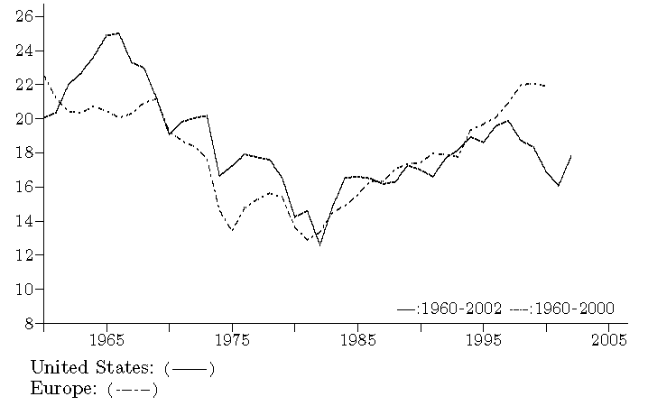
The unit of analysis is the total private economy. Profits in the numerator are equal to the net product minus the total cost of labor (with a wage-equivalent for self-employed persons). The denominator is the stock of fixed nonresidential capital. Such a measure of the profit rate is appropriate in a discussion of the determination of profit rates by technology and wages, as in Marx's analysis. Another definition must be used to assess profitability levels as “felt” by firms, as in figures 2 and 3.

One can also notice, parenthetically, the quite conspicuous decline of the profit rate in the U.S. economy after 1997. It is the combined effect of the rise of the cost of labor during the long boom and the impact of the recession after 2000, since profit rates are always diminished during recessions.
Other measures of the profit rate are displayed in figures 2 for France, and 3, for the U.S.. (The unit of analysis is now nonfinancial corporations.) These figures provide a measure of the profit rate of firms closer to their practice than in figure 1: (1) Narrower definitions of profits are used; (2) Capital is equal to the net worth of firms (or shareholder's equity, i.e., assets minus debt). The followings are noteworthy:

Figure 2. France, nonfinancial corporations: Profit rates prior to the payment of real interest and after, %
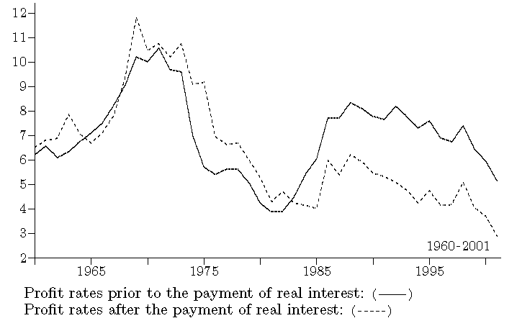

Figure 3. U.S., nonfinancial corporations: Profit rates prior to the payment of real interest and after, %
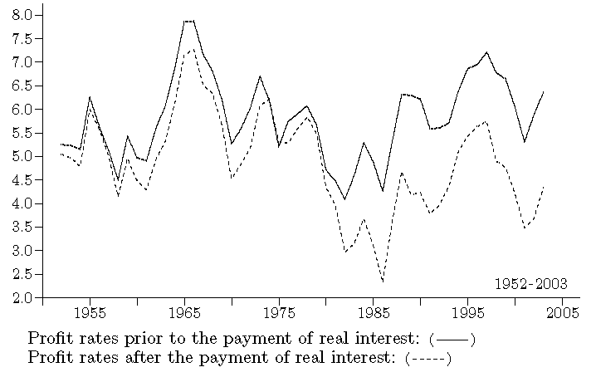
In the first series, profits are equal to the net product minus the cost of labor, and business and profit taxes. They are divided by the net worth (total assets minus debt). For the second series, real interest is subtracted from profits, i.e., interest minus a correction for the depreciation of debt resulting from inflation.

1. In the first series (―), profits are measured after tax. Consequently, profit rates are lower than those in figure 1. In spite of the differences in definitions and the consideration of France instead of three European countries, profit rates in these figures confirm a certain recovery of the profit rate.
2. The second series (---) document the impact of interest payments, actually real interest, i.e., interest after a correction for the devaluation of debt by inflation. Profits are now computed after subtracting for such real interest payments:
(a) Before 1982, the two measures remained very close, in spite of the rather large indebtedness of firms. Inflation was actually compensating for interest payment, with a real interest rate nearly equal to zero. The devaluation of debt by inflation was offsetting the payment of interest.
(b) The cost of indebtedness became larger in the following years, diminishing significantly the profit rate. In France, the weight of interest nearly nullified the underlying recovery of the profit rate. In the U.S., the profit rate after real interest also remained consistently lower than before interest since the early 1980s.
Figure 4 provides a direct measure of the impact of interest on the profit rates in France and in the U.S.. It displays the ratio of real interest to the net worth of corporations, the measure of capital used in figures 2 and 3, in the two countries, i.e., the “profit rate loss”. In France about 2.4 percentage points of profit rate were lost due to interest payment from the mid-1980s onward, and 1.7 percentage points in the U.S..
As shown in figure 5 for the U.S., the rise of both long-term and short-term real interest rates was very sudden, from the negative values of the 1970s to nearly 8% (average 1981-1985) for long-term and short-term real rates. In spite of the ephemeral decline of short-term rates, during recessions, in the early 1990s and since 2001, the two rates are still large.
Thus, a first major finding of this investigation is that the sudden rise of interest rates
prolonged the effects of the crisis, as the benefits of the recovery of firms' profitability were transferred to lenders. The extension over time of these low profit rates largely accounts for the weak investment behavior of firms, the low rates of growth and, thus, the difficulty to reabsorb the large masses of unemployed people, particularly in Europe.
As can be expected under such circumstances, firms attempted to diminish this burden of debt, but this process proved difficult as a result of price stability and low profitability levels. This observation points to a second important finding, concerning the comparative impact of this transfer of profits to finance in the various countries in recent years. It is already evident from an examination of figures 2, 3, and 4 that this transfer was larger in France than in the U.S., due to the larger indebtedness of firms. Thus, countries in which debt was an important component in the financing of firms, like France or Japan, suffered considerably more than those where it was not so, as the U.S.. In France, the effort to reduce debt is often pointed out as a crucial factor accounting for lower investment performances (B. Paranque, 1995). These attempts were manifested in the very large rates of self-financing (above 100%) that were observed in France during the 1990s.

Figure 4. U.S. and France, nonfinancial corporations: Ratio of real interest (net interest minus the devaluation of debt by inflation) to net worth, %
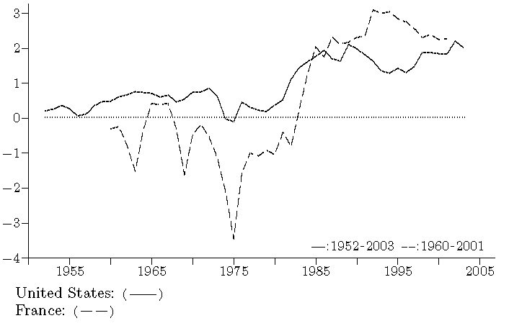
Ratio of real interest to net worth
 | Average  1960-1979  (A) | Average  1985-2001  (B) | Increase  (B)-(A)
United States | -0.8% | +2.4% | +3.2%
France | +0.5% | +1.7% | +1.2%

Figure 5. U.S.: Long-term and short-term real rates of interest, %
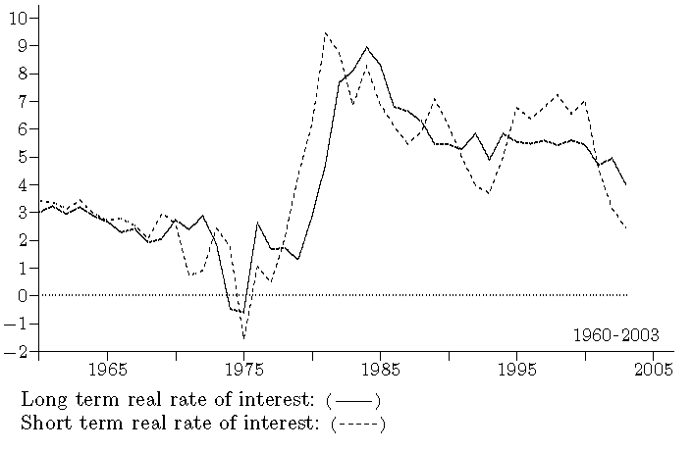

The measures of profit rates in figures 2 and 3 are established before the payment of dividends to shareholders. Another characteristic of neoliberalism is that a considerably larger fraction of profits is distributed as dividends: in the early 2000s, nearly the totality of profits (compared to 30% during the 1970s). The consequences on the investment of nonfinancial corporations are also dramatic.
Not only firms, but all agents holding a significant stock of debt were hurt by the policy of 1979. This was particularly true of the state. First, from the early stages of the crisis, the sagging rates of growth of output affected the progression of the revenue of the state, when expenses were increasing at a slower pace than before. The adjustment of the growth rate of public expenses to that of output (and taxes) was achieved gradually. Only the continued pressure on expenses and the rapid growth of the revenue in the later years allowed for the dramatic recent disappearance of the deficit in the U.S.. Second, in most major capitalist countries, the public debt tended to decline during the first decades after World War II. A considerable fraction of this debt was, however, financed by short-term securities. When interest rates grew in the early 1980s, these securities were issued at the higher interest rates. Interest jumped, and the debt itself began to rise rapidly.
It is quite remarkable that, under such conditions, no deficit of public finance is observed in most countries (with fluctuations over time), independently of interest payments. It was so in Germany, the United Kingdom, and France, and to a lesser extent in the U.S.—Italy representing a major exception.
Starting with the observation that, independently of interest payments, budgets would have remained approximately balanced, can we conclude that the rise of interest rates caused the deficits? This discussion is highly political, and the apologists of neoliberalism develop the opposite line of argument, contending that deficits actually caused high interest rates (and, thus, unemployment can be blamed on deficits—that they impute to excess welfare expenses...)! In our opinion, this line of argument is entirely misleading. Our interpretation is that, during a period of low profit rates, finance dramatically widened the alternative channel for the appropriation of a surplus (besides the traditional profit channel), that of taxation and interest payments, thus causing deficits. One possible objection by neoliberals is that deficits would have been even larger if the rise of interest rates had not required a strict control of expenses. This objection boils down to the assertion that large deficits were necessary to impose a policy of control, but not any deficits (not those following from the slowdown of revenue at a faster pace than expenses), a specific type of exogenous deficits, even larger and cumulative, profitable to lenders. True, high interest rates made the deficit so large that outlays had to be curbed!
The burden of indebtedness was also manifest for households or, more exactly, for a certain fraction of households. This situation is difficult to assess for various reasons. The population of households is quite heterogeneous; one fraction, in particular the wealthiest, lends while others borrow; this latter group is also quite heterogeneous (for example, there is a large difference between a manager, whose position is well established, borrowing to buy a new house, and an unemployed worker engaged in short-term borrowing to get along.) Large differences are also observed among countries. In a quite distinct context, a similar rise of the debt of households occurred in the U.S. beginning in 1985. After a lasting period of fluctuation around 65% since the early 1960s, the ratio of the debt of all households to their disposable income rose sharply to 115% in 2003 (and no decline is observed in recent years contrary to France). This surge of the indebtedness of households poses a considerable threat on the future of U.S. macroeconomy.
One of the most detrimental effects of the change in monetary policy in the U.S. was the debt crisis in third-world countries, and the unbearable burden placed on these countries. The violence of the shock is well depicted in figures 6 and 7. (We consider here all developing countries, as defined by the World Bank.)
1. Figure 6 displays the apparent real interest rate paid by these countries (the ratio of interest paid to the outstanding debt, minus the rate of inflation in the U.S.). These rates were first negative during the 1970s, during the years of rapid growth of the debt stimulated by such favorable conditions. Then, one can observe the sharp rise of the real interest rate in the early 1980s.
2. The rising weight of indebtedness is strikingly demonstrated in figure 7. This figure plots the ratio of the total debt service (interest and principal) to the exports of these countries. From 1971 to 1977, this ratio fluctuated around 8%. The situation began to deteriorate in the late 1970s, when these countries were increasingly going into short-term debt. The sudden rise of interest rates transformed this threat into a disaster. Within a few years, the ratio of the service of the debt to exports rose beyond 20%, before stabilizing around 17%.
3. These movements are reflected in the variations of the the GNP of these countries (measured in dollars). During the first period of negative real interest rates, GNP was growing rapidly. Then, this growth of output gave way to a sharp decline. A fall of 33% was observed between 1979 and 1985. In 1996, it had not yet recovered its level of 1979!
These observations are so clear that it appears hardly necessary to make any additional comment. A strategy for development, based on indebtedness—whose relevance should be discussed—was suddenly transformed into an actual catastrophe by a decision emanating from a fraction of ruling classes within leading capitalist countries, with a total indifference for the hardship imposed on the third world (as well as for the rise of unemployment everywhere).

Figure 6. Developing countries: Real apparent rate of interest, %
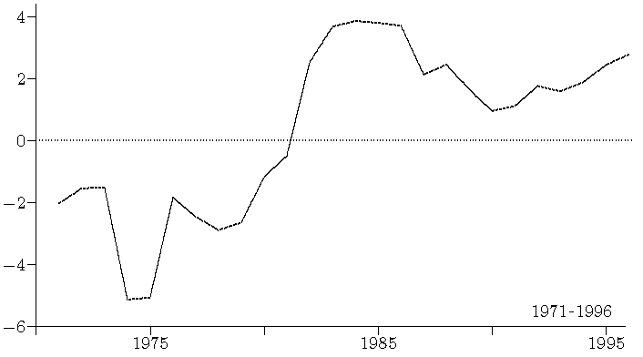
It is the ratio of interest paid to the outstanding debt, minus the rate of inflation in the U.S..

Figure 7. Developing countries: Ratio of the total debt service (interest and principal) to the exports, %
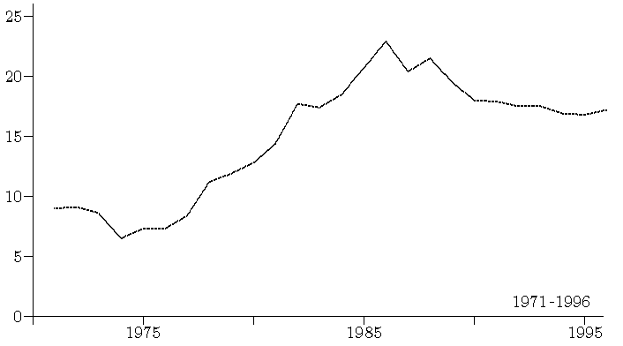

3 - Who benefits?
The contention that a ruling class may benefit from a situation of structural crisis will be considered implausible by many, including some of those who have a rather critical view of capitalism. Is not crisis detrimental to everybody? Such views radically underestimate the antagonistic character of capitalism. Beyond the basic idea of exploitation, of the appropriation of surplus-value, the crisis that began in the 1970s and the rise of neoliberalism provide a remarkable illustration of the class contradictions underlying capitalism.
The example of inflation, described in the previous section, is quite telling of the basic tensions concerning power and income, and of their class foundations. When the profit rate declined in the 1970s, a formidable transfer of income from lenders to borrowers resulted from the acceleration of inflation. From the viewpoint of borrowers, it corrected for the effects of the declining profit rate (compensating for interest payment).
This situation can be better understood when put in historical perspective, in comparison to the earlier decades. As was contended earlier, the power of finance had been diminished in the wake of the Great Depression although the profitability of the financial sector had been maintained in the U.S. The acceleration of inflation and the fall of real interest rates added to the earlier diminished importance of financial markets, stricter regulation, increased managerial discretion within large corporations, or the relative autonomy of government officials with respect to the narrow interest of finance. Finance reversed, in the straightforward sense of the word, these trends to its own advantage, gaining in two respects.
First, finance defined, or rather reestablished, rules guaranteeing its supremacy. This represents a first facet of neoliberalism, the establishment of a new social order. In all countries, finance set up new strategies targeted to the control of any social forces that could impede its progress. Lasting unemployment provided the necessary conditions for the control of the labor cost; public deficits were used to break the dynamics of welfare expenses; a new corporate governance targeted to the interest of shareholders was imposed on management; the debt crisis, and later the financial crises of the 1990s, allowed for the imposition of the neoliberal model to the third world. And we abstract here from the political aspect of these movements.
Second, finance attracted huge amounts of income in a general environment of strong tensions on distribution. It simultaneously used the traditional channel of income transferred from production, and the channel of taxation and interest payments (as holder of public securities). What we mean here is simple and straightforward: Finance increased tremendously its income during the 1980s and 1990s, even relatively to its earlier situation prior to the crisis. A few figures will be sufficient to illustrate the point.
Below, we document these evolutions in three respects: (1) the income of households; (2) stock-market indexes; (3) the profit rates of financial corporations.
1. We first build an index of the effects of neoliberal policies on the income and assets of households. A fraction of households holds significant monetary and financial assets, and derives an income (interest, dividends, and capital gains) from some of them. In addition, the price of some of these assets, like shares of stock, undergoes important variations that must also be considered. The current value of these assets must finally be corrected for inflation, since they represent a diminished purchasing power, because of rising prices. Figure 8 depicts the evolution of the ratio of these gains resulting from the holding of monetary and financial assets (actually gains or losses) to the disposable personal income of households. We will not discuss here the overall difference in levels between the two countries which basically mirrors the larger importance of shares, at market values, within the monetary and financial assets of households in the U.S.. Relevant to our investigation is the profile of the variable over time:
(a) Up to 1983, losses were observed in France: during the 1970s, an average of -9.1% of the total income of households. The ratio oscillated around +5.3% in the U.S. during the same decade, with two observations below zero. This loss or low remuneration of monetary and financial assets reflected mainly the devaluation of these assets by inflation, in a period in which the growth rate of the stock market was smaller than the rate of inflation (see figure 9).

Figure 8. U.S. and France: Ratio of the gains or losses of households over their outstanding monetary and financial assets, to their disposable income, %
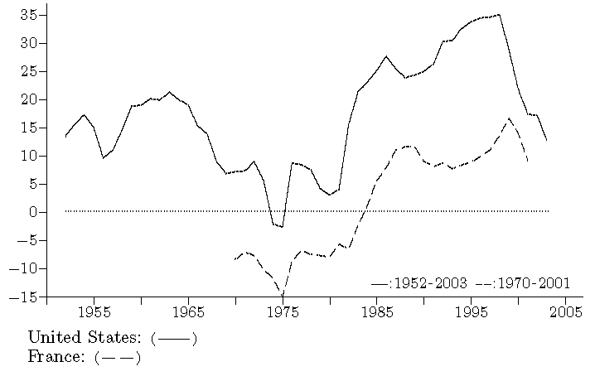
These gains are the aggregate of: (1) interest and dividend received by households; (2) gains resulting from the rise of the stock market; (3) minus the devalorisation of all their monetary and financial assets (balance of various accounts, securities, and shares) resulting from inflation.

Figure 9. U.S., Germany, France, and United Kingdom: Stock-market indexes, corrected for inflation (1965=1)
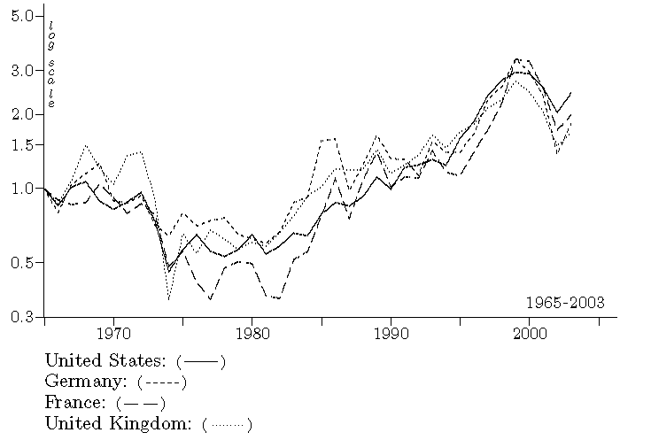

(b) The effects of the change in policy and the fight against inflation are dramatically apparent in figure 8, from the mid-1980s onward. In both countries, the series rose sharply. In France, after 1987, the ratio fluctuated around +11% of the income of households. But this evolution reached truly amazing proportions in the U.S., with a first plateau around 25% between 1983 and 1991 (reaching levels larger than those of the 1960s), and an upward trend during the 1990s to about 35% in 1998 (because of the simultaneous rise of the stock market and stability of prices). This would have been previously hard to imagine. As evident in the figure, the fall of the stock market in the early 2000s encroached considerably on these gains.
Thus, the conclusion is unambiguous: In the 1980s, it became quite profitable to hold monetary and financial assets, in sharp contrast to the earlier period.
2. An examination of the price of stocks confirms this diagnosis. In figure 9, the stock-market index of each country, U.S., Germany, France, and United Kingdom, was divided by its own GNP deflator. All indexes move strikingly in tandem: They all fell during the 1970s, remained at low levels (twice lower) for about a decade, from the mid-1970s to the mid-1980s, and then headed upward dramatically, up to a level about three times larger than that prevailing prior to the crisis. Again, the recovery of finance appears strikingly.
3. The way in which the financial sector used the crisis to improve its situation is also obvious from an examination of its profitability. Figures 10 and 11 compare the profit rates of financial and nonfinancial corporations, respectively in France and the U.S.. The same definition of the profit rate is used as in figures 2 and 3 for the nonfinancial sector. The profit rate for financial corporations includes capital gains (or losses):
(a) In both countries, one observes that the profit rate of financial corporations was comparatively low during the 1970s. In France, it was even negative. This must be related to the importance of the public sector in the French financial system.
(b) An upward trend is apparent from the 1980s onward. The proportions and rapidity of this recovery were amazing in France. Neoliberalism was responsible, in France, for a thorough transformation of the financial system. In the U.S., a very strong heterogeneity developed within financial institutions. The 1980s were marked by the banking and thrift crises—in which the rise of interest rates played a crucial role (FDIC, 1997)! For a few years, these developments hid the underlying recovery of profitability within the financial sector. Finally, the effects of the new monetary policy became manifest providing the financial sector with large profit rates in the late 1980s.
(c) In both countries, the dramatic rise of the profit rate during the second half of the 1990s is the expression of the increase in stock-market indexes. Thus, the effect on profits (numerator of the profit rate) of holding gains is larger than the increase in the net worth of corporations (denominator of the profit rate) due to the rise of the value of financial assets. The last year in the series, 1999, corresponds to the stock-market peak.
Any economist familiar with classical or Marxist economics, examining figures 10 and 11, expects that such a modification of comparative profit rates initiated a migration of capitals seeking larger profit rates (K. Marx, 1894, Ch. 10). As could be expected, capitals “rushed” toward the financial corporations when the profit rate in this sector soared.

Figure 10. France: Profit rate of nonfinancial and financial corporations sector, %
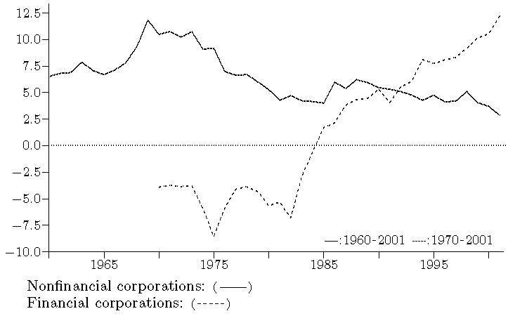

Figure 11. U.S.: Profit rate of nonfinancial and financial corporations, %
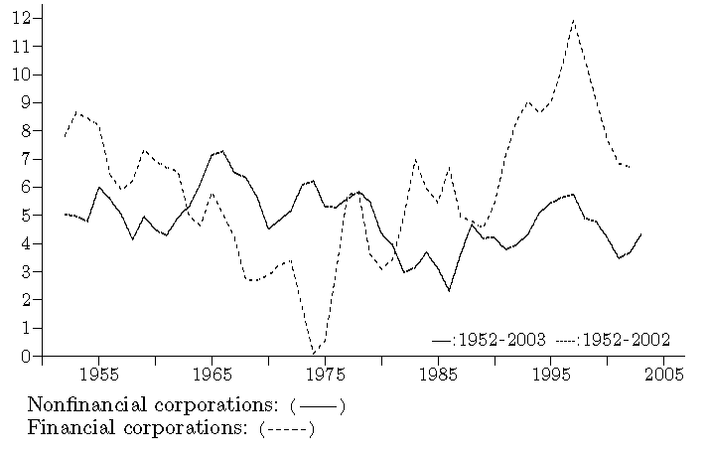
The profit rate for nonfinancial corporations is that used in figures 2 and 3 (---). For financial corporations, the series has been slightly filtered to avoid short-term fluctuations.

Figure 12 plots the ratio of the net worth of financial corporations to that of nonfinancial corporations in the U.S.. During the 1960, the ratio was about 15%. It declined to 11% during the first phase of the crisis, prior to the rise of neoliberalism. Then, it soared above 30% in 1999. This fluctuation reflects the variation of stock indexes but also actual capital flows. While the banking and thrift crises were raging, capital was already flowing toward finance. This recalls that profit rates such as those displayed in figure 11 account for the average profitability in the sector, hiding possibly very large heterogeneity. The rise of real interest rates simultaneously contributed to the failure of many institutions (notably because of the default on their loans, in particular commercial real estate loans), while creating very favorable conditions for others. Simultaneously to this rise of financial corporations, nonfinancial corporations developed their financial activity. In the U.S., comparing the 1990s to the 1970s, the ratio of the monetary and financial assets of nonfinancial corporations to their tangible assets was increased.

Figure 12. U.S.: Ratio of the net worth of financial corporations to that of nonfinancial corporations, %
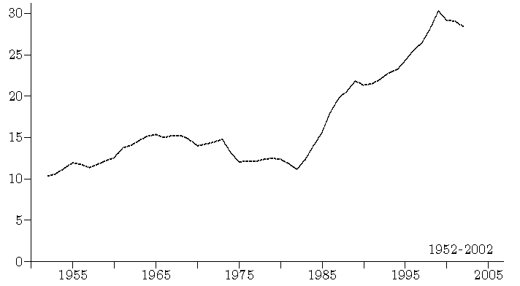

These trends are one expression of what has been denoted as “financialization”. We do not suggest here that financial capital has acquired an intrinsic aptitude to valorization, but that the rise of interest rates biased capital allocation in favor of financial investment. Was this movement detrimental to physical investment? This difficult issue relates to the overall dynamics of accumulation in capitalism and complex macroeconomic mechanisms, and its discussion lies beyond the limits of the present study.

4 - The strength of finance and financial fragility
Neoliberalism is the expression of the new hegemony of finance. It is, therefore, not surprising that finance reshaped many basic features of contemporary capitalism. These patterns can be better understood when considered in historical perspective, beginning with the transformation of relations of production in the early 20th century recalled in the first section.
A basic aspect of capitalism in the 20th century is the growing gulf and autonomy between the ownership of the means of production vis-à-vis these means of production. The separation of ownership and management made possible this evolution, since business requires a day-to-day presence and concern, which is now collectively carried out by managerial and clerical personnel. On the basis of this separation, a whole set of institutions was, however, implemented, in particular the so-called markets (for securities and currencies), which make this autonomy possible.
From the standpoint of finance, the investment of funds should remain reversible. After having been invested in a particular field, these funds should always be allowed to withdraw rapidly and at minimum cost. There are two aspects in this free movement of capital: (1) the right to enter and exit from a field of investment; (2) the ensuing ability to move from one field to another. Historically, finance was constantly active building the institutions required for this mobility. The stock exchange is the most conspicuous element, but all monetary and financial markets are at issue. Any holder of a security or currency must be allowed to sell or buy at any point in time. Neoliberalism pushed these mechanisms to the extreme, eliminating regulatory limitations.
There is an obvious contradiction between the necessary lasting investment in production, with its specific risks, and this absolute freedom of movement demanded by finance. Nonfinancial firms must confront the structural crises following from the possibly unfavorable trends of technology and distribution (trajectories à la Marx), as well as the recurrent recessions of the business cycle, and adapt to the constant pressure of competition. Finance attempts to use its own institutions to obtain protection against these risks, thanks to its ability to withdraw, attempting to impose the consequences of these movements on others. Doing so, it can considerably deepen the crises or even create new crises and, therefore, jeopardize growth and employment. We have shown earlier in this study how finance prolonged the effects of the structural crisis of the 1970s within major capitalist countries. The role it plays in the Japanese crisis has often been described. Is it necessary to recall here the examples of Mexico, South-East Asia, or Russia, etc. (P. Gowan, 1999)?
This is, therefore, the last indictment that we will direct toward neoliberalism: The contemporary transformations of capitalism may lead to crises in which monetary and financial mechanisms play a central role, adding to the inherent instability of the system. If, following the suggestion in the title of this paper, one seeks to assess the comparative costs and advantages of neoliberalism, these crises appear as a major component of costs.

REFERENCES
Albritton R., Itoh M., Westra R., Zuege A. (ed.), 2001, Phases of Capitalist Development: Booms, Crises, and Globalization, Palgrave, London, Basingstoke.
Berle A., 1960, Power without Property, Harcourt, Brace, New York.
Brenner R., 1998, "The Economics of Global Turbulence", New Left Review, Vol. 229, pp. 1-264.
Burns A.R., 1936, The Decline of Competition, A Study of the Evolution of the American Industry, McGraw-Hill, New York.
Chandler A.D., 1977, The Visible Hand. The Managerial Revolution in American Business, Harvard University Press, Cambridge, Massachusetts, London, England.
Conseil National du Crédit, 1995, Rapport annuel 1995, Fiche thématique num. 7, Paris.
Domhoff G.W., 1990, The Power Elite and the State. How Policy is Made in America, Aldine de Gruyter, New York.
Dowd D., 1989, The Waste of Nations. Dysfunction in the World Economy, Westview Press, Boulder, London.
Duménil G., Lévy D., 1993, The Economics of the Profit Rate: Competition, Crises, and Historical Tendencies in Capitalism, Edward Elgar, Aldershot, England.
Duménil G., Lévy D., 1996, La dynamique du capital. Un siècle d'économie américaine, Presses Universitaires de France, Paris.
Duménil G., Lévy D., 2001, "Periodizing Capitalism. Technology, Institutions, and Relations of Production, pp. 141-162, Ch. 9", in Albritton R., Itoh M., Westra R., Zuege A., 2001.
Duménil G., Lévy D., 2002, "The Nature and Contradictions of Neoliberalism, pp. 97-119”, in Panitch L., Leys C., 2002.
Duménil G., Lévy D., 2003, Économie marxiste du capitalisme, La Découverte (Repères), Paris.
Duménil G., Lévy D., 2004a, Capital Resurgent. Roots of the Neoliberal Revolution, Harvard University Press, Boston.
Duménil G., Lévy D., 2004b, The Economics of U.S. Imperialism, MODEM, CEPREMAP, Paris, http://www.jourdan.ens.fr/levy
FDIC, 1997, History of the Eighties. Lessons for the Future, Federal Deposit Insurance Corporation, Washington.
Ferguson T., Rogers J., 1986, Right Turn. The Democrats and the Decline of American Politics, Hill and Wang, New York.
Galbraith J.K., 1969, The New Industrial State, Penguin Books, London.
Gowan P., 1999, The Global Gamble. Washington's Faustian Bid for World Dominance, Verso, London.
Helleiner E., 1994, States and the Reemergence of Global Finance. From Bretton Woods to the 1990s, Cornell University Press, Ithaca, London.
Henwood D., 1998, Wall Street, Verso, London, New York.
Hilferding R., 1981, Finance Capital: A Study of the Latest Phase of Capitalist Development (1910) , Routledge and Kegan Paul, London, Boston.
Kleinknecht A., Mandel E., Wallerstein I. (ed.), 1992a, New Findings in Long Wave Research, Macmillan Press, London.
Kleinknecht A., Mandel E., Wallerstein I. (ed.), 1992b, New Findings in Long Wave Research, Macmillan Press, London.
Kolko G., 1963, The Triumph of Conservatism: A Reinterpretation of American History, 1900-1916, The Free Press of Glencoe, London.
Marx K., 1894, Capital, Volume III, First Vintage Book Edition, New York, 1981.
Mizruchi M., Schwartz M. (ed.), 1987, Intercorporate Relations. The Structural Analysis of Business, Cambridge University Press, Cambridge.
Moseley F., 1992, The Falling Rate of Profit in the Postwar United States Economy, St. Martin's Press, New York.
Moseley F., 1997, "The Rate of Profit and the Future of Capitalism", Review of Radical Political Economics, Vol. 29, num. 4, pp. 23-41.
Panitch L., Leys C., 2002, A World of Contradictions (Socialist Register 2002), Monthly Review Press, New York.
Paranque B., 1995, Compétitivité et rentabilité des entreprises industrielles, Banque de France, B95/06, Paris.
Roy W.G., 1996, Socializing Capital: The Rise of the Large Industrial Corporation in America, Princeton University Press, Princeton.
Shaikh A., 1992, "The Falling Rate of Profit as the Cause of Long Waves: Theory and Empirical Evidence", in Kleinknecht A., Mandel E., Wallerstein I., 1992.
Soref M., Zeitlin M., 1987, "Finance Capital and the Internal Structure of the Capitalist Class in the United States, pp. 56-84", in Mizruchi M., Schwartz M., 1987.
Useem M., 1984, The Inner Circle, Large Corporations and the Rise of Business Political Activity in the U.S. and U.K., Oxford University Press, Oxford.
van der Pijl K., 1984, The Making of an Atlantic Ruling Class, Verso, London, New York.
Veblen T., 1983, The Engineers and the Price System (1921) , Transaction Books, New Brunswick.
Weinstein J., 1968, The Corporate Ideal in the Liberal State, 1900-1918, Beacon Press, Boston.
Wolff E., 1992, "Structural Change and the Movement of the Rate of Profit in the USA", in Kleinknecht A., Mandel E., Wallerstein I., 1992.

+ MODEM-CNRS, Université de Paris X-Nanterre, 200, av. de la République, 92000 Nanterre, France. Email: gerard.dumenil@u-paris10.fr.
++ CEPREMAP-CNRS, 48, bd Jourdan, 75014 Paris, France. Email: dominique.levy@cepremap.ens.fr.
See G. Duménil, D. Lévy, 1993, 1996, 2001, 2002, and 2004a. A synthesis, in French, can be found in G. Duménil, D. Lévy, 2003.
The paper does not discuss the cases of the Chinese and Indian economies, which developed rapidly during the last 20 years in spite of the assertion of global neoliberalism.
An exception is D. Henwood, 1998.
Data are from: (1) BEA (National Income and Product Accounts and Fixed Assets Tables) and the Federal Reserve (Flow of Funds Accounts), for the U.S. ; (2) INSEE (Institut National de la Statistique et des Études Économiques) and La Banque de France, for France ; (3) OECD, for Europe ; and (4) the World Bank, for third-world countries.
The merger wave was traditionally interpreted as a decline of competition (A.R. Burns, 1936). Gabriel Kolko emphasized quite appropriately the fact that it did not diminish competitive pressures in the U.S. economy, rather the contrary (G. Kolko, 1963).
This is where we diverge with Gabriel Kolko who tends to interpret the rise of managerial and clerical personnel as a path toward bureaucratisation (G. Kolko, 1963). We also fundamentally disagree with the analysis of monopoly capitalism, which combines the decline of competition and the rise of bureaucracies, described as a waste of resources culminating in the 1970s (D. Dowd, 1989, ch. 2, and p. 71).
See the first chapter, Class formation on an Atlantic scale, of K. van der Pijl, 1984. Pilj provides a framework of analysis of class patterns in relation to Marx's analysis, that we cannot discuss here.
There is an interface between these classes, the world of boards of directors where owners still engaged in some form of management and top managers, owners to certain degrees, collaborate. It is crucial to the survival of managerial capitalism.
One refers, for example, to liberalism concerning capitalism in the U.S. during the first half of the 19th century, that of Andrew Jackson, based on the opposition between small owners and what was already called monopolies (big business). The utilization of the same term, liberalism, for the Progressive Era, from the late 19th century to World War I, already implies a new definition. What is the common aspect between the various periods described as liberal? James Weinstein is probably right in the introduction to his book when he writes: “Both in its nineteenth and twentieth century forms, liberalism has been the political ideology of the rising, and then dominant, business groups”, and this with various contents (1968, p. xii). Weinstein's book was written before the emergence of contemporary neoliberalism, but his idea can be easily prolonged to this new age of liberalism. Thus, the malleability of the notion is truly extraordinary, since it successively applied to the ideologies of: (1) small owners, attached to the principles of free competition, in the middle of the 19th century ; (2) the new financiers and managers of corporations, in the early 20th century during the establishment of the institutions of modern capitalism ; (3) finance reasserting its hegemony, during the late 20th century.
In the early 1980s, Kees van der Pijl described the “Resurgence of Money Capital” and the “New Empire of High Finance” (K. van der Pijl, 1984, ch. 9). See also M. Useem, 1984. In their analysis of the assertion of neoliberalism, Ferguson and Rogers have shown that the consolidation of neoliberalism cannot be reduced to the rise to the fore of the reactionary forces originally backing Margaret Thatcher or Ronald Reagan, but that President Reagan had to adjust his policies in line with other business groups, that Ferguson and Rogers label Internationalists, related to international finance “leading international financiers” and leaders of multinational corporations in general “with the best and most sophisticated managements” (T. Ferguson, J. Rogers, 1986, p. 47).
Such evolutions of power relations are always reflected within academic circles. Paralleling the struggle of finance for dominance against Keynesianism, the faculties of big universities were working on a synthesis of the various trains of thought underlying this confrontation, called the neoclassical synthesis. The rise of finance during the inflation years was paralleled by the affirmation of monetarism. The dominance of neoliberalism was accompanied by the preeminence of the Chicago school.
G. Duménil, D. Lévy, 2004b.
A synthesis of our earlier work is presented in G. Duménil, D. Lévy, 1993 and 2004a. See also, F. Moseley, 1992, and 1997 ; A. Shaikh, 1992 ; E. Wolff, 1992 ; and R. Brenner, 1998.
In the U.S., the shares issued by nonfinancial corporations and held by nonfinancial corporations are not included within the assets (and the net worth of the sector is reduced correspondingly). The flow of dividends received is also net of dividends paid by corporations of the sector to other corporations of the sector. Thus, the shares held as assets by nonfinancial corporations are basically Foreign direct investment abroad. This is not the case within the French national accounting framework: All shares held and dividends are considered, and it is not possible to separate between the two types of shares and dividends. To make the comparison more relevant, we do not include shares held by French nonfinancial corporations in their assets when we determine net worth, and we also exclude dividends received from profits.
In the U.S., the alleviation of profit taxes acted as a countertendency to the falling profit rate.
The real interest rate is equal to the nominal rate minus the inflation rate: i_{R}=i-j. Multiplying both sides of this equation by, D, the net debt stock (debt minus monetary and financial assets), it comes out that the real income transfer from borrowers to lenders, real interest, is equal to the sum of interest paid, iD, minus the devaluation of debt by inflation, jD: i_{R} D=iD-jD.
Real interest rates, respectively long-term and short-term, were still 4.8% and 4.3% for the average of 2000-2003, to be compared with 3.0% and 3.1% for the average of 1961-1965.
This proves even more difficult for smaller firms (Conseil National du Crédit, 1995).
G. Duménil, D. Lévy, 2004a, ch. 9 (figures 9.5 and 9.6) and 14.
In France, this had been approximately performed in 1982. In between, the proportion of total public expenses (which in France include health insurance and retirement) in total GNP soared from 40% to 50%.
In the U.S., the flow of net interest paid by the government represented about 28% of total after tax corporate profits, from World War II to the early 1980s. During the 1980s, this ratio more than doubled, and its average for 1981-1990 was 98%.
In France, for example, much emphasis has been placed recently on the so-called “overindebtedness” of certain households. In the aggregate, in France, households appear as lenders, but a considerable fraction of households holds a large debt. The rise of the mass of debt occurred in the late 1980s. These households were the victims of the duration and intensity of the crisis. Because of the early stimulative policy of the socialist government, reaching power in 1981, France was not affected by a recession in 1982, contrary to the United States. The adjustment was made gradually during the following years but, overall, with the same violence. At the end of 1986, the French economy went into a large recession after several years of constant pressure downward to curb inflation (the so-called “period of austerity”), and households went suddenly into debt.
Debt is in dollars.
It partially mirrors the large variation of the rate of exchange of the dollar during those years.
Obviously, this statement does not imply that the earlier course of events was favorable in every respect.
What we consider here is the effect of holding monetary or financial assets, independently of borrowings.
For the gains over the holding of shares, we smoothed the series (by filtering) to eliminate short-term fluctuations.
If the actual figure is used for capital gains, instead of a smoothed series, the ratio reaches 71% in 1999!
For both the U.S. and France, we do not include “funds” in the financial sector. In the U.S., this refers to Pension funds, Mutual funds, and Bank personal trusts, which are treated as directly held by households within national accounting frameworks. In France, we similarly set aside the OPCVMs (Organismes de Placement Collectif en Valeurs Mobilières). Contrary to the U.S., it is not possible to consider Insurance for France, since the determination of the profits is problematic for this industry. In the U.S., one can define a private financial sector, excluding the Federal Reserve and government agencies. This is not the case for France, where this public sector was very important and is still considerable. In addition, major banks were successively nationalized and denationalized.
On this issue, Marx basically followed Smith and Ricardo.

